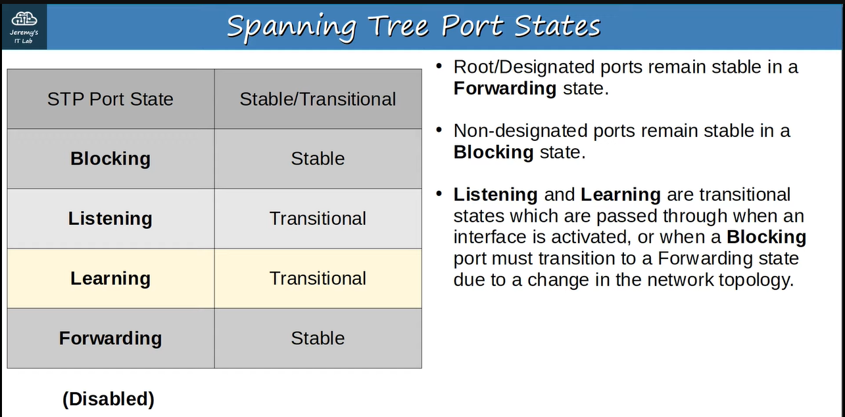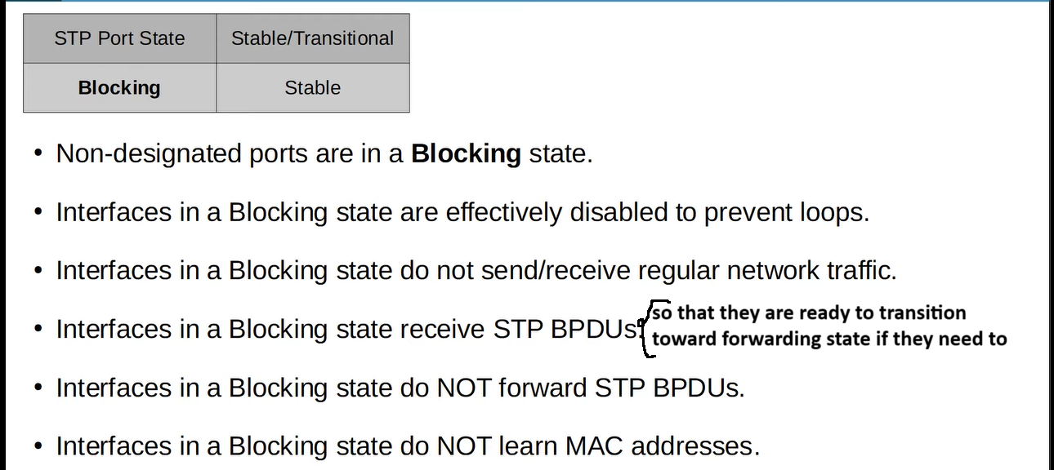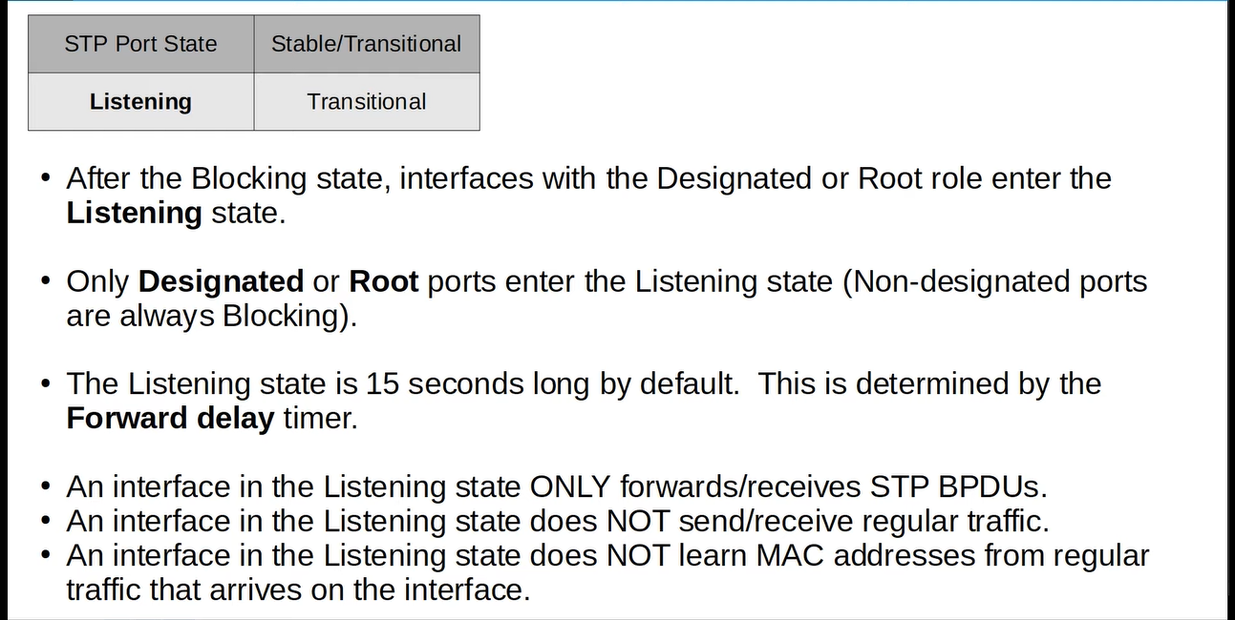

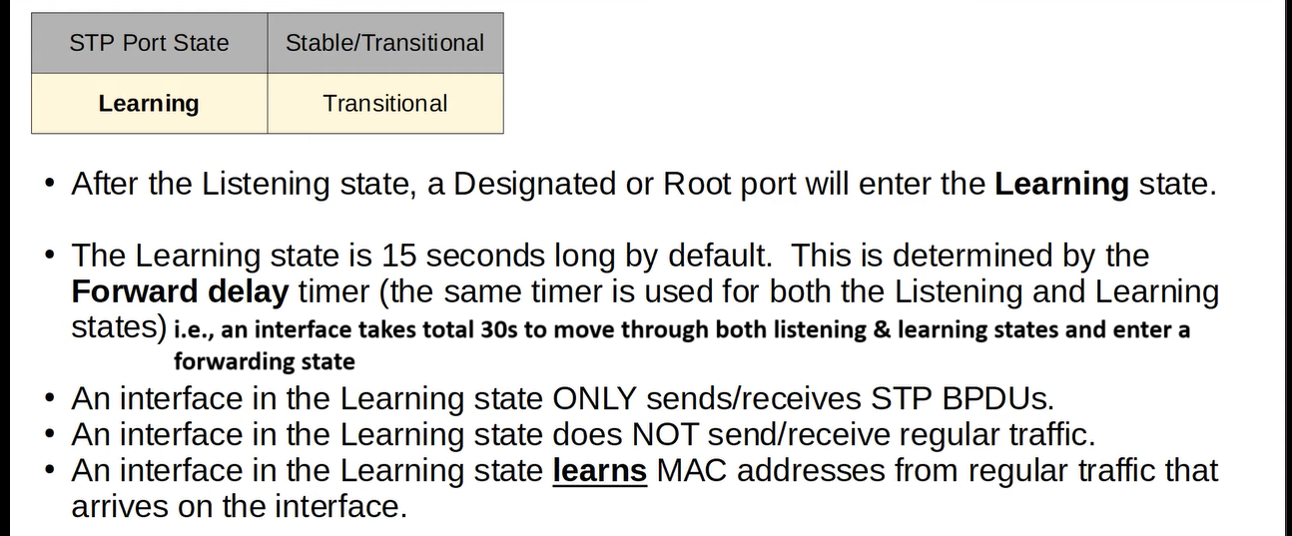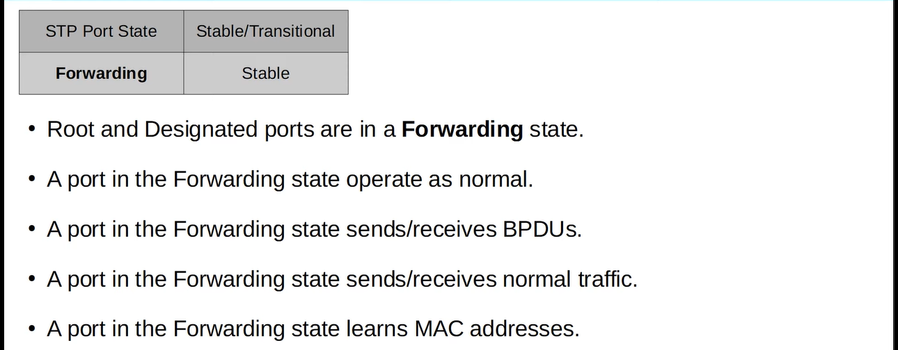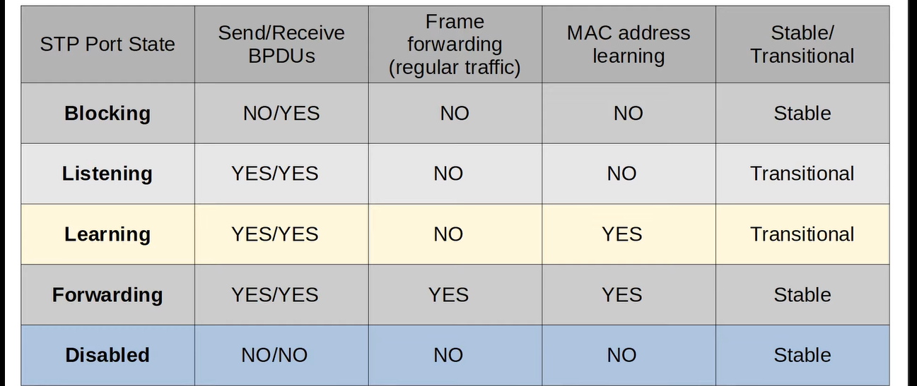

**Now we will see spanning tree timers, but remember first time all switches send their hello-BPDU and after selecting a root bridge only root bridge can send the hello-BPDU and other switches forward it through their designated interface only.**

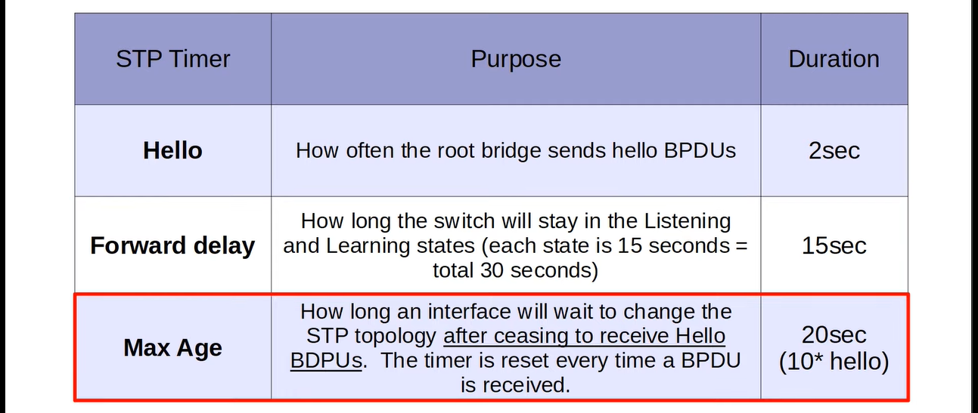**the root bridge will send hello-BPDUs in every 2s.**

**Let’s understand it with an example ↓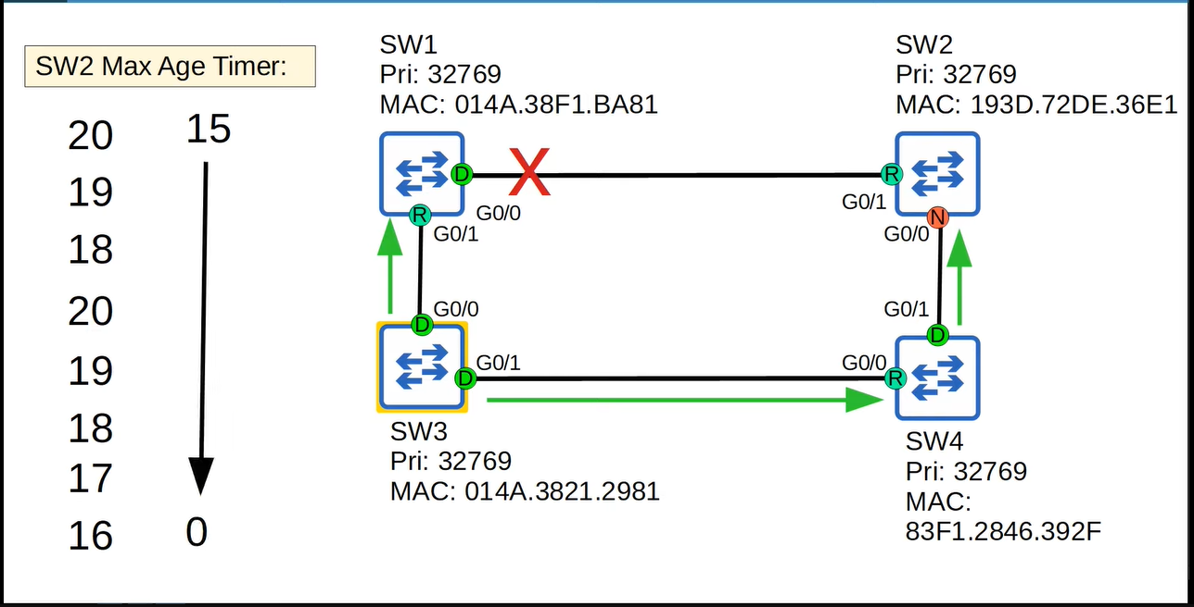The root bridge SW3 is sending hello-BPDUs and, after every 2s, all switches reset their Max-Age timer to 20s but, due to some reason, SW1 cannot send it and SW2 cannot receive it and if once the SW2 completes its 20s of Max-Age then it will start to move to the forwarding state ↓**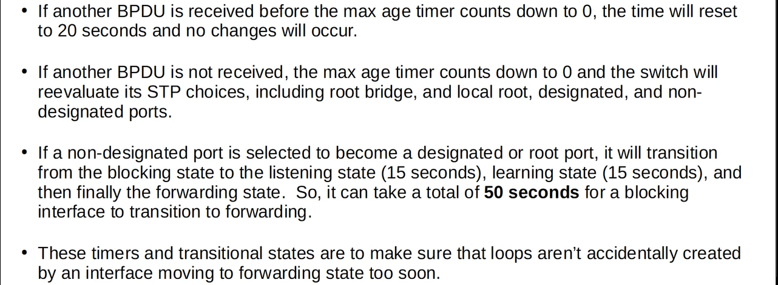

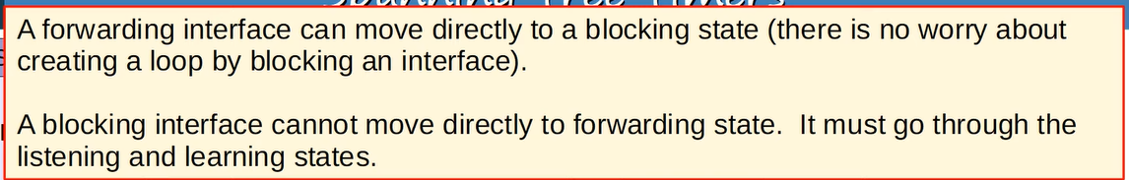**Wireshark capturing ↓**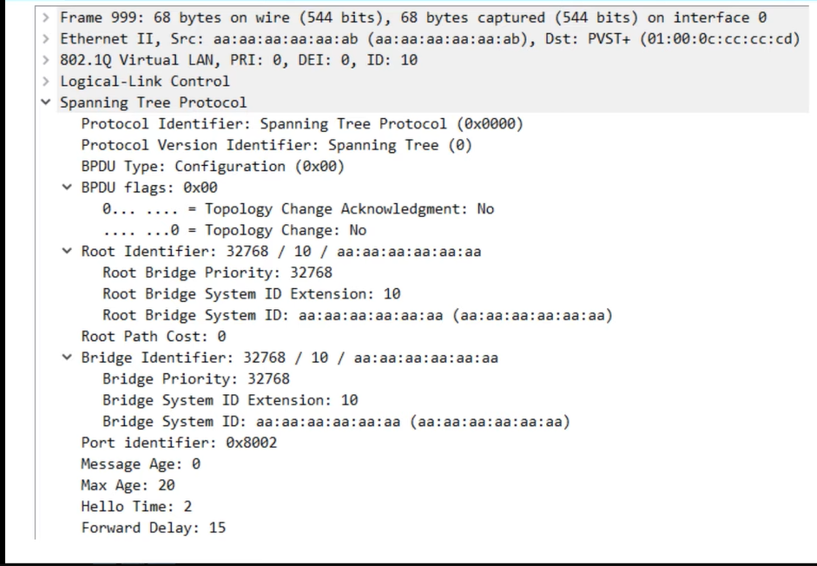

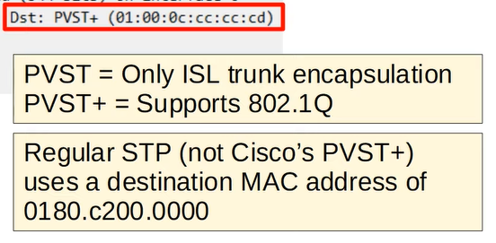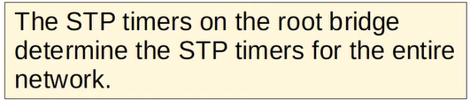

**Now we will see the features of STP that improves the functionality of STP**

**1) Portfast ↓**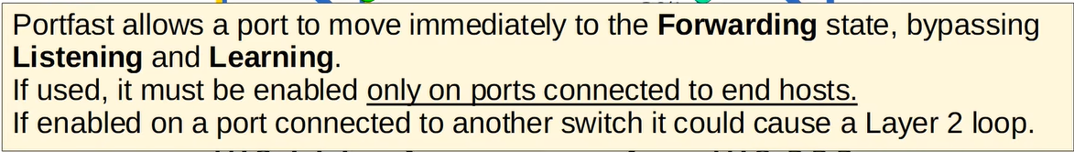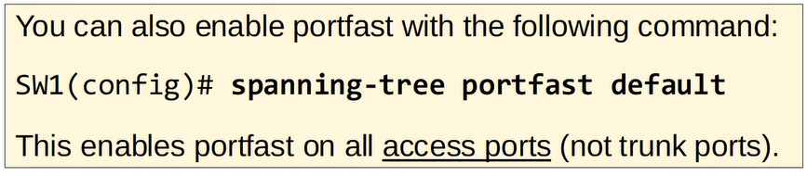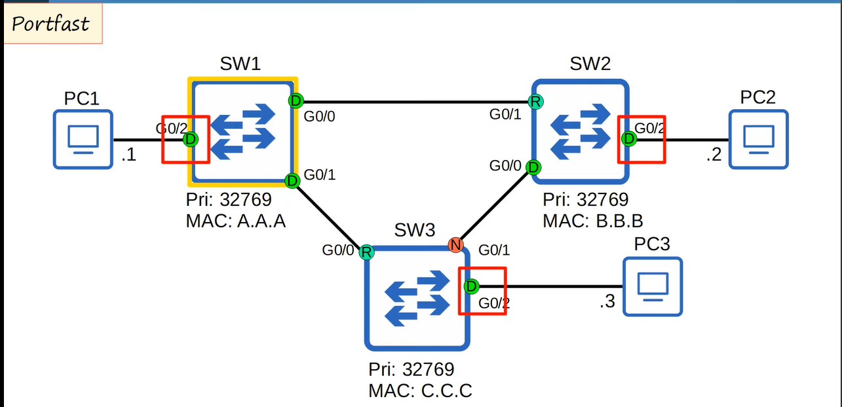

**Configuration ↓**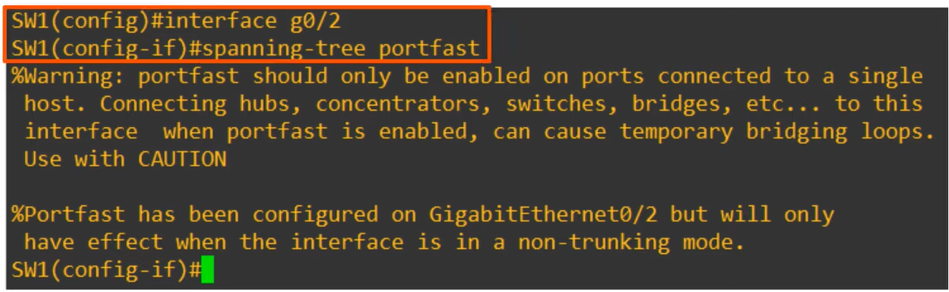

**2) BPDU Guard ↓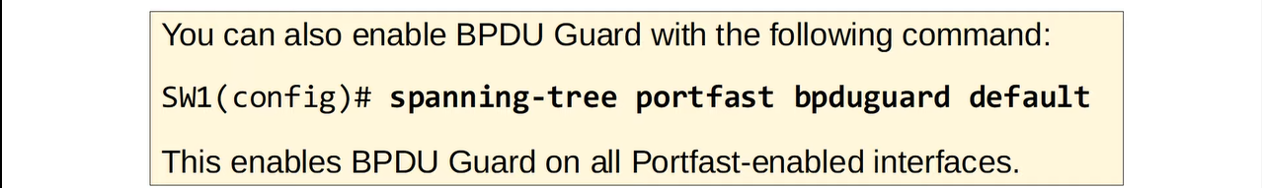Configuration ↓The port will be disabled after receiving BPDU ↓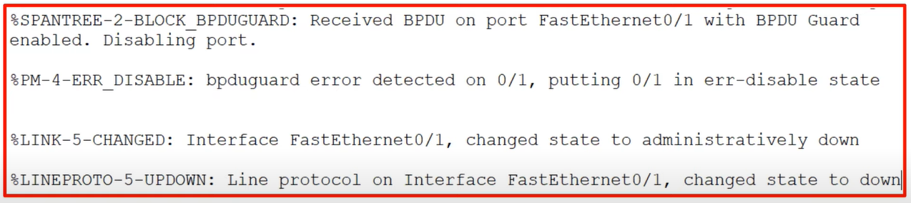After that, to enable that port ↓**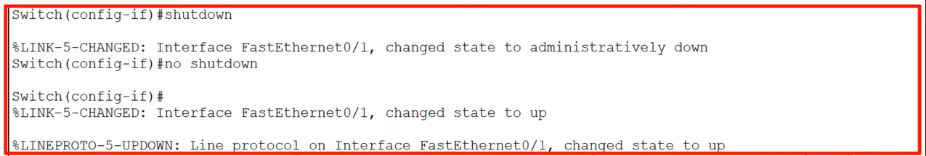

**3) Root Guard & 4) Loop Guard ↓**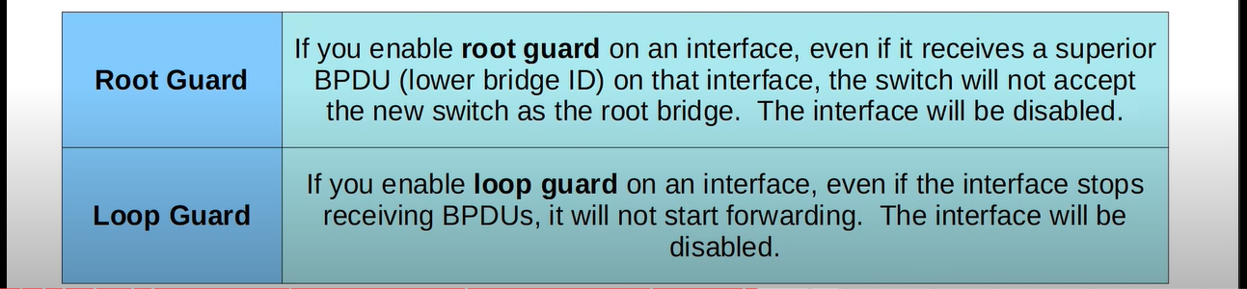

**Now we will see the configuration of STP, this topology we will use ↓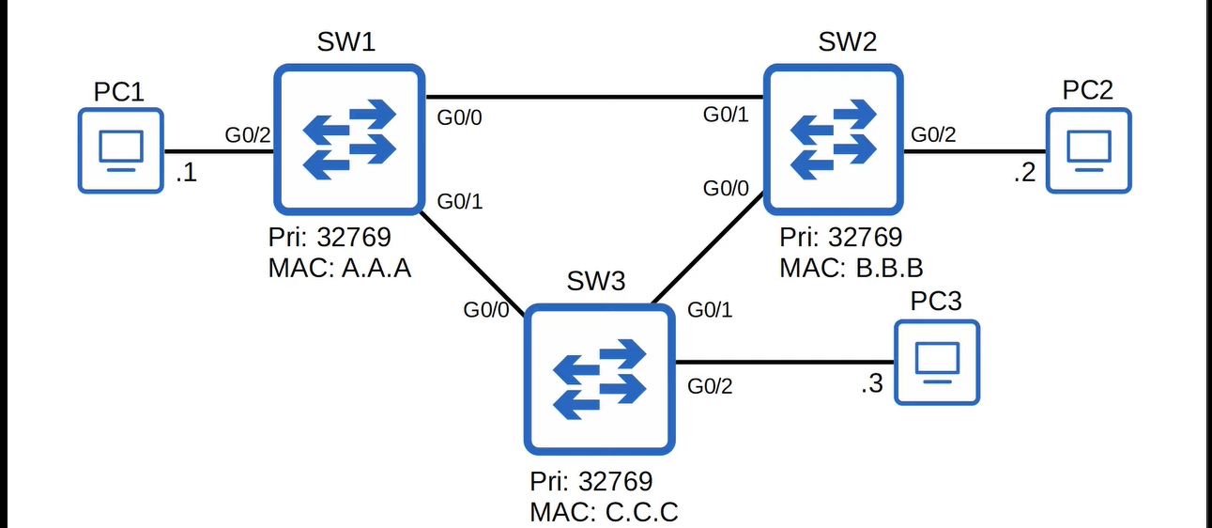 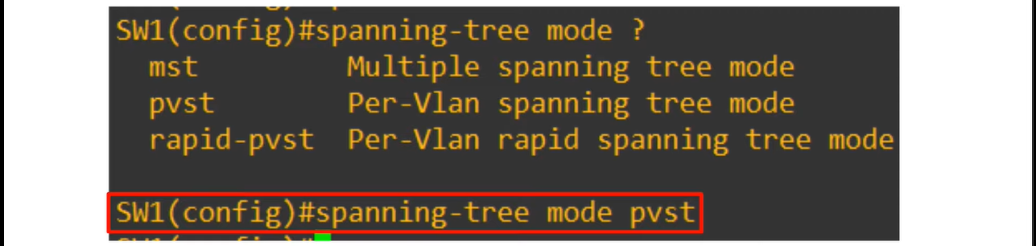 For now, SW1 is root bridge, but we can configure SW3 to be the root bridge ↓**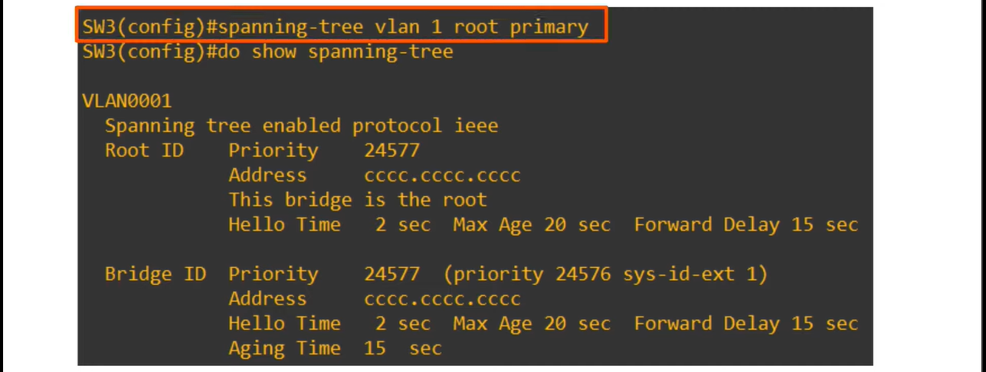

**we can also configure SW2 as “secondary root bridge” ↓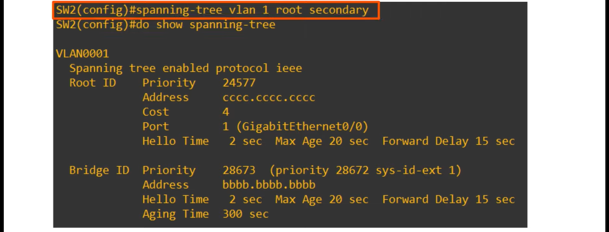Now ↓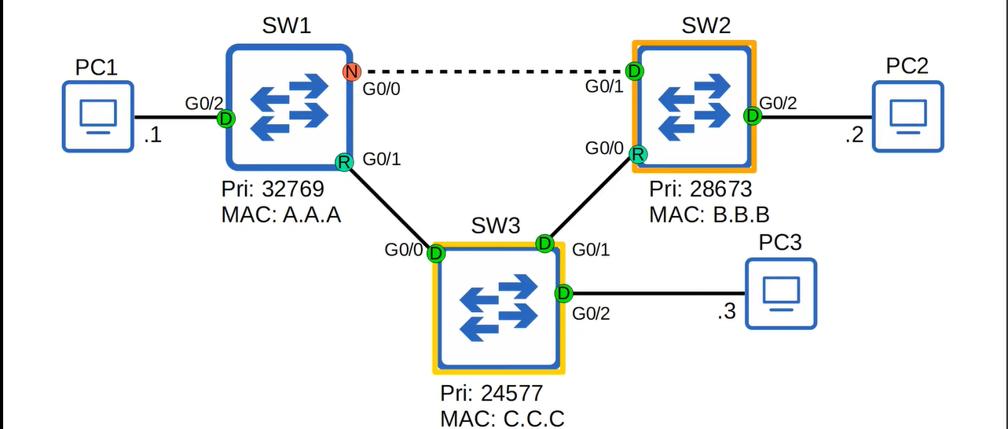This is the topology for VLAN1 but the topology for VLAN2 ↓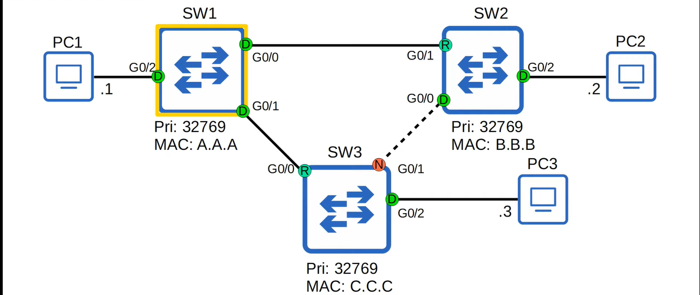and this is called “STP Load-Balancing”**